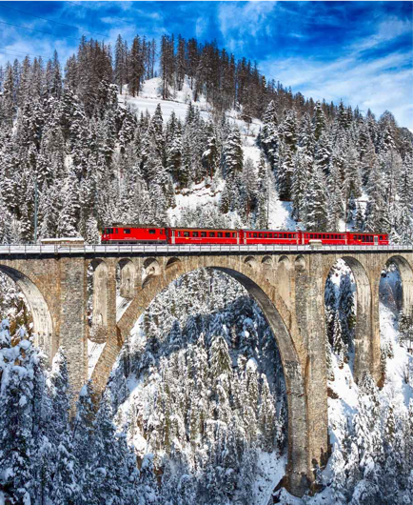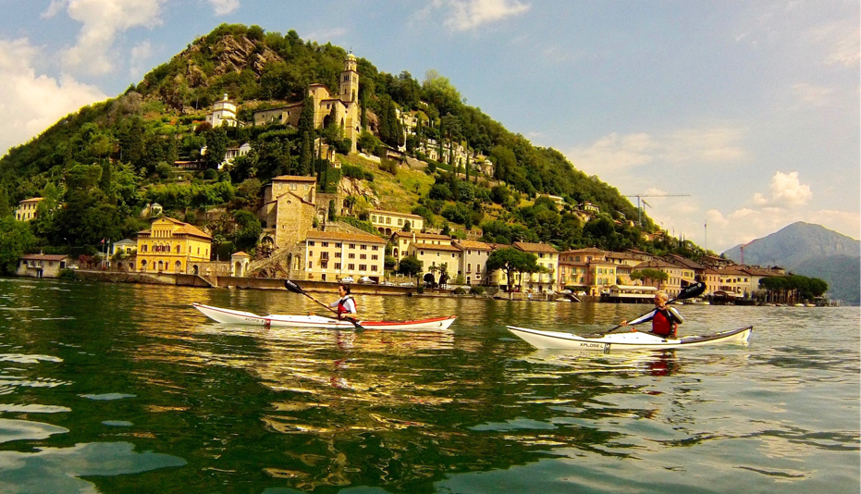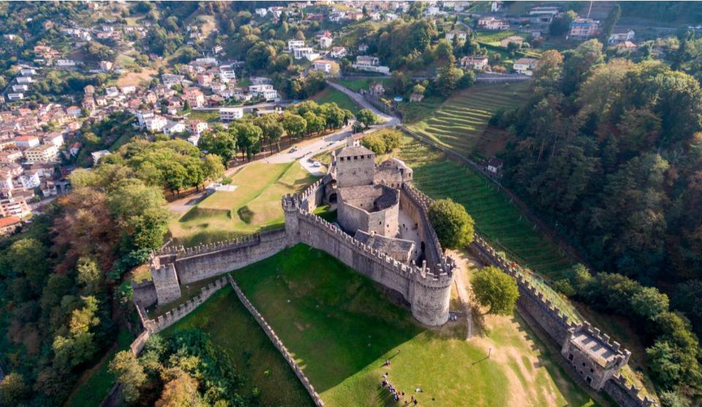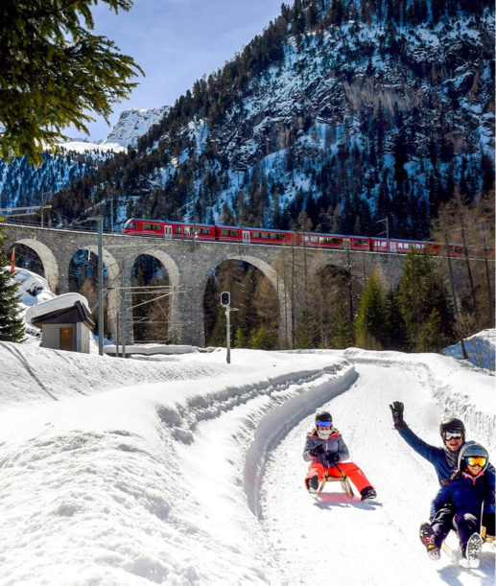
Adventure in the Alps. Swiss trip 2023
A 9 days adventure, fly to and from Milano Malpensa , pick up and logistic full included small groups.
- - Paddling Lake Lugano and explore the city
- - Hike the Tibetan bridge in Monte Carasso
- - Visit the castle of Bellinzona Unesco World Heritage
- - Famous Red Train of Bernina Unesco World heritage
- - Sledging in the world famous Preda - Bergun
- - Snowshoes on the Cardada Mountain over Lake Maggiore
www.kayakxplore.com email: travelinkayakriviera@gmail.com Tel + 39 349 7762051

